Faculty of Computer Science and Information Technology
Industrial Training
Semester 8, Session 2017/2018
Documentation Guidelines
GUIDELINES FOR FINAL REPORT
1. Introduction
These guidelines relate to the preparation and submission of Industrial Training’s Final Report. Any matter that is not mentioned herewith may be referred to the respective IUTT supervisors in your Faculty.

2. Submission
The last date for submission of the Final Report is on the 14-07-2018 . Students must submit the Final Report to his/her respective IUTT supervisor of their faculty.

3. Specifications and Instructions for Submission of Industrial Training Final Report
3.1 Form of Submission
One (1) hard copy-comb bound in black.

  - Language
Report must be written in English.

  - Font
Use font size 12 and font type, ‘Times New Roman’ throughout the Report. The font type for chart, graph, diagram etc can be different according to the format and space. Only ‘letter quality’ or ‘near letter quality’ printing is acceptable (including map, diagram and graph).

  - Paper
The Report must be printed on A4 size paper of 80 grams in weight. The paper should be white in colour, acid free and ‘non-erasable’.

  - Corrections
Any correction must be made carefully. Any page that contains untidy corrections will be rejected and students will have to replace those pages.
  - Page Margins
To facilitate binding, the minimum page margins shall be as follows:

Left and Top margin : 40mm
Right and Bottom margin : 25mm

  - Spacing

One and a half spacing (Double spacing is also accepted) should be used, except for tables where single spacing is allowed.

  - Pagination

Every page except the title page must be numbered. Title page is “i” but it is not numbered.

Preliminary Pages are to be numbered in lower case Roman numerals (ii, iii, iv, etc.).

Main Text and Reference Material should be numbered with the Arabic numerals (1, 2, 3, 4, etc.).

- Format

The Report must include the following parts:

Part I - Preliminary Pages
Part II - Main Text
Part III - Reference Material

Part I – Preliminary Pages

Part I shall include the followings:

- Cover Page

The form and contents of the title page must follow the format given. The title shall be capitalised. Please refer to format (at page 7 herein).

- Copyright Notice Declaration

Please refer to the format at page 8.

- Declaration

Please refer to the format at page 9.

- Acknowledgment

This is a brief acknowledgement of assistance given to the student in researching and writing of the Report. Please refer to the format at page 10.

- Dedication (if any)

Please refer to the format at page 11.

- Abstract

It should be concise and clear and include important details about the scope of the training of the student. The length should be between 100 to 200 words. Please refer to the format at page 12.

- Table of Contents

Table of Contents (TOC) shows readers the starting page number of each major section and subsection in the report. Please refer to the format at page 13. The topics to be covered in the report must be carefully selected and organised. The flow of the topics to be presented is very important in order to guide a relatively novice reader in understanding the whole report. To an experienced reader, the TOC enables a quick search for the information of interest.

- List of Tables/Diagrams (if any)

This provides the list of tables, full title and page numbers. Tables must be numbered consecutively in order of appearance.
The List is to enable readers to find the illustrations, diagrams, charts, and tables in the report.
- Lists of Figures (if any)

Figures (i.e. graphs, photographs and other illustrative material) are to be listed on a separate page. Figures must be numbered in Arabic numerals consecutively (Fig 1, 2, 3 or 2.1, 2.2, 2.3, etc) in order of appearance and captioned.

Part II – Main Text

Descriptive details of each of the student’s tasks/assignments which he/she is engaged, presentation of work done and discussion on Findings/Results must be provided. The Main Text should normally be divided into chapters as listed below:-

Chapter 1 Introduction

An introduction is necessary to give an overview of the overall topic and the purpose of the report. The motivation to the initialisation of the training can be included. Its content should be general enough to guide the reader gracefully into the subject materials.

Chapter 2 Employer’s Background

State the background of the employer to whom the student is attached to during the Industrial Training.

Chapter 3 Training Projects/Tasks/Assignments

Description/Diagram

Achieving the Tasks/Assignments/Projects

Problems Encountered and Ways to Improve Tasks/Assignments/Project based learning experience

Chapter 4 Feedback / Findings

Feedback and findings on the Industrial Training.

Learning gained: a comparative experience and matching with the theories imparted in Class.

Chapter 5 Conclusions and Recommendations

Training Analysis

Knowledge, Skill, Attributes and Others (KSAO) acquired.

Suitability, weaknesses, ways to improve, etc
Recommendation to Other

Part III – Reference Material

The Reference Material may consist of:-

- Appendices (Other documents, if any)

The section contains lengthy materials which are not of sufficient general interest to be included inside the Main Text for example, comments and remarks by the external supervisor, employer’s structure and its group structure (if applicable), and other relevant documents.

- References

Every reference quoted or cited in the report must be included in the list of references and be numbered accordingly. Citation is required for statement which expresses a fact that goes beyond the common knowledge of the art.

- Marking Scheme

The Final Report will be marked based on the following criteria:

- Planning and organising 25% (10 marks)
- Description of tasks/projects 25% (10 marks)
- Learning or applications of skills 25% (10 marks)
- Analysis and problem solving 25% (10 marks)
100% (40 marks)

Important note:
The total 100% (40 marks) will contribute towards 16% of the Total grade for the course.

Prepared by the Head of Industrial Training
International University of Technology Twintech - IUTT
Tel: (01) 427570
Fax: (01) 427572

Date: Mar 10, 2016

Documentation Guidelines Template B version 1.0 / 2016
Industrial Training
BIT 2024/2025
Final Report

Ali Khaled Abdullah

2122221975

Digital Art for Trading
Taiz Street, Sana'a, Yemen
7796879..

Mr. Ahmed

15 December 2024 – 13 March 2025

Mr. Sadeq Salah Al-Din

Faculty of Computer Science and Information Technology
International University of Technology Twintech

Semester 8 – Session 2024/2025
Date of Submission: May 2025

DECLARATION

I hereby declare that this report titled "Industrial Training Report" is the result of my own work and has not been submitted to any other institution for any academic award. This report is submitted in partial fulfilment of the requirements for the Bachelor of Business Information Technology (Hons) program at the International University of Technology Twintech.

Signature: ____________________

……………………
© Ali Khaled Abdallah Saleh
2122221975
_________________
All rights reserved

ACKNOWLEDGEMENT

With sincere appreciation, I would like to begin by thanking the Almighty for granting me the strength, clarity, and resilience to complete this industrial training journey with purpose and perseverance.

I extend my heartfelt gratitude to Digital Art for Trading, a company that not only welcomed me into its technical environment but also entrusted me with responsibilities that challenged my creativity, problem-solving, and adaptability. I am especially thankful to Mr. Ahmed, my external supervisor, for his constant encouragement, real-world insights, and for treating me not as a trainee, but as a budding professional capable of contributing meaningfully.

My deep appreciation goes to my university supervisor, Mr. Sadeq Salah Al-Din, whose mentorship, timely feedback, and academic guidance were instrumental throughout my training. His support ensured that I remained grounded in academic rigor while exploring practical challenges.

I am also grateful to the Faculty of Computer Science and Information Technology at the International University of Technology Twintech, whose vision for hands-on education continues to shape students like myself into industry-ready graduates.

Last but not least, I thank my family for being my emotional anchor, and my peers and friends for their camaraderie and inspiration during this transformative phase of my academic career.

DEDICATION

I dedicate this report to my parents, whose unconditional love, perseverance, and sacrifices have been the foundation of every step I’ve taken in my academic life.

To my late-night supporters and early-morning motivators — thank you for believing in my potential even when I doubted myself.

This report is also dedicated to every aspiring student navigating the balance between learning and working — may this journey inspire excellence, patience, and ambition.

Lastly, to the developers, engineers, and mentors at Digital Art for Trading who welcomed me as a peer and challenged me to grow — this is for you.

ABSTRACT

This report documents a 12-week industrial training undertaken at Digital Art for Trading, a technology-focused company specializing in smart systems and mobile application development, based in Sana’a, Yemen. The training was conducted as part of the Bachelor of Business Information Technology (Hons) programme at the International University of Technology Twintech, fulfilling a vital academic requirement that bridges classroom learning with practical field experience.

Throughout the internship, I was actively engaged in various phases of mobile app development, beginning with fundamental training in Flutter Flow and progressing to the design and implementation of a functional health monitoring application. My responsibilities included creating user interfaces, integrating Firebase as a backend database solution, handling authentication flows, and deploying application components for testing on real devices. These experiences not only reinforced theoretical knowledge acquired in academic courses such as Database Management and Mobile App Development but also enhanced my problem-solving skills and ability to work in a fast-paced technical environment.

Additionally, I gained exposure to real-world project coordination, time management between academic and industry commitments, and collaborative development within a professional team. This report encapsulates the technical tasks completed, challenges encountered, lessons learned, and reflections on the alignment between academic theory and professional practice.

TABLE OF CONTENTS

Declaration ........................................................................................................................i
Acknowledgement ........................................................................................................ ii
Dedication ......................................................................................................................... iii
Abstract ............................................................................................................................ iv
Table of Contents .......................................................................................................... v
List of Figures ................................................................................................................. vi
Chapter 1: Introduction .......................................................................................... 1
Chapter 2: Employer’s Background ................................................................. 3
Chapter 3: Training Projects, Tasks, and Assignments ........................ 5
• Phase 1: Orientation and Foundational Skills
• Phase 2: Interactive UI Design and Page Linking
• Phase 3: Full App Development and Backend Integration
• Phase 4: Export, Custom Logic & Finalization
• Summary of Skills Gained
Chapter 4: Feedback and Findings ................................................................... 10
• Alignment with Academic Knowledge
• Feedback from Supervisors
• Observations and Key Learnings
• Reflection on Personal Growth
• Challenges Encountered
Chapter 5: Conclusion and Recommendations ........................................ 14
• Conclusion
• Recommendations to the Company
• Recommendations to the University
APPENDICES A
References C

LIST OF FIGURES

Figure 3.1 Screenshot of the application from inside Flutterflow ...................…...9
Figure 3.2 Image of the AI chat in the MediSense program ............................... 9

Chapter 1: Introduction
Industrial training is an integral component of undergraduate education, designed to provide students with real-world exposure, professional development, and the opportunity to apply academic knowledge within a practical environment. As part of the Bachelor of Business Information Technology (Hons) programme at the International University of Technology Twintech, this 13-week industrial training placement at Digital Art for Trading was undertaken to fulfill that academic requirement while equipping me with hands-on experience in software development, database integration, and industry practices.

Digital Art for Trading, located in Sana’a, Yemen, is a growing tech company specializing in smart solutions such as surveillance system integration and mobile applications for monitoring and security. My internship within this dynamic environment introduced me to the life cycle of app development, beginning with design through Flutter Flow, backend configuration using Firebase, and culminating in testing and deployment. From day one, the company fostered a professional yet collaborative atmosphere, allowing me to gradually shift from observation to active development responsibilities.

The primary objective of this training was to bridge the theoretical frameworks acquired through university courses—such as cloud computing, system analysis, and mobile application design—with tangible deliverables. Moreover, it served as a platform to develop essential soft skills including time management, task prioritization, and team communication, all within the constraints of a live technical project.

This report presents a structured account of my internship journey. It highlights the employer’s background, the tasks and projects I was involved in, the challenges and solutions encountered, and the insights gained. It also reflects on the alignment between academic instruction and industry expectations, concluding with recommendations for future interns and reflections on professional growth.

Chapter 2: Employer’s Background
Digital Art for Trading is a privately-owned technology solutions provider headquartered on Taiz Street in the heart of Sana’a, Yemen. Founded in May 2023, the company was established in response to the growing demand for integrated smart systems and mobile-first applications within the Yemeni market. Despite being relatively young, Digital Art for Trading has built a reputation for its innovative use of low-code platforms and cloud-based infrastructure to deliver responsive, scalable, and user-centric digital products.

The company’s core services revolve around two primary domains: (1) the installation and support of advanced surveillance and security systems, and (2) the development of mobile applications that allow for remote control and monitoring of these systems via smartphones. This dual focus reflects the company’s vision to converge hardware and software solutions into seamless smart ecosystems for both commercial and individual users.

Organizationally, the company operates through three major departments:
- Technical Development, which includes software developers, mobile UI/UX designers, and system integrators.
- IT Support & Maintenance, which manages technical troubleshooting, repairs, and onsite implementations.
- Sales & Customer Operations, responsible for client engagement, market outreach, and end-user training.

During my training, I was embedded primarily within the Technical Development department, where I worked under the mentorship of Eng. Ahmed Al-Kumaim, a senior engineer with extensive experience in cross-platform mobile development and real-time database integration. His leadership style emphasized practical learning, autonomy, and iterative development—allowing me to transition from theoretical understanding to active project contribution within the first few weeks.

The company culture is collaborative and growth-oriented, with an open-door policy that encourages knowledge sharing across roles. Weekly technical discussions, informal brainstorming sessions, and performance reflections were common practice. This learning environment empowered me to interact with professionals beyond my immediate scope, including UI designers and database administrators, providing a holistic understanding of app development pipelines.

One of Digital Art’s defining technological advantages is its adoption of Flutter Flow, a modern low-code UI builder for Flutter that accelerates the design-to-deployment process, especially when combined with Firebase for backend services. These tools aligned perfectly with the training objectives of my academic program and helped bridge theoretical coursework with actual field application.

Beyond technical implementation, the company’s role in the local tech ecosystem cannot be understated. It actively collaborates with emerging startups and educational institutions, and its training program aims to develop future-ready professionals equipped to contribute to the digital transformation of Yemen’s growing technology sector.

In summary, Digital Art for Trading provided not just a placement, but a professional ecosystem where I was able to observe, learn, contribute, and grow. Its agile structure, commitment to innovation, and supportive work culture made it an ideal environment for this crucial phase in my academic and professional development.

Chapter 3: Training Projects, Tasks, and Assignments
This chapter provides a detailed account of the technical tasks, development assignments, and learning activities undertaken during my 13-week industrial training at Digital Art for Trading. The training was strategically structured into three progressive phases—each building on the skills acquired in the previous one. These phases not only reflect the technical trajectory of my development as a trainee but also align with the real-world workflow of mobile app projects in agile development environments.
- Phase 1: Orientation and Foundational Skills (Weeks 1–4)
During the initial phase, I was introduced to the working culture, tools, and responsibilities expected of a junior developer. The first few days involved onboarding activities such as meeting department heads, understanding the company’s product ecosystem, and observing the development workflow.
Key tasks:

Repaired hardware (printers, desktop PCs) as part of early support assignments to understand how hardware and software coexist in real-time environments.

Installed and explored Flutter Flow, a low-code platform for building Flutter-based mobile applications.

Practiced creating basic interactive components (buttons, forms, navigation links) and establishing page hierarchies.

Attended university lectures in parallel, balancing academic obligations with real-world training.
This period laid the technical foundation and introduced me to essential UI/UX concepts, event handling, and component logic within a visual development interface.

- Phase 2: Interactive UI Design and Page Linking (Weeks 5–7)
Building upon my initial exposure, the next phase involved deeper engagement with application prototyping and navigation architecture. I was tasked with designing complex page flows for a prototype mobile application focused on healthcare. Technical Application: My background in Business Information Technology helped me contribute meaningfully when working alongside the software development team. I suggested minor UI improvements in the e-wallet application interface and contributed to organizing the help desk knowledge base.
Key tasks:

Designed and linked multiple pages using Flutter Flow’s page routing system.

Created user login, registration, and profile update pages.

Connected these interfaces to Firebase, enabling cloud-based user authentication and data persistence.

Participated in quality assurance efforts by testing page responsiveness, field validations, and user flows.

Collaborated with UI designers and backend developers to ensure alignment between interface design and data structures.
This phase was critical in transitioning from frontend-only interactions to integrating backend services. I learned how to translate static design components into functional, interactive experiences.

- Phase 3: Full App Development and Backend Integration
(Weeks 8–12)
In the third phase, I became responsible for building the core modules of a health monitoring mobile application. This included both frontend and backend integration using Firebase’s Realtime Database and Firestore.

Key tasks:

Created reusable components for displaying patient vitals and health records.

Integrated complex Firebase collections and sub-collections to handle user-specific data.

Designed data write operations for user-submitted health information (e.g., heart rate logs).

Enhanced the interface with list views, dynamic fields, and responsive layouts.

Conducted iterative testing on physical Android devices to simulate real-world usage and debug input/output flow.

Worked under time constraints to deliver functional modules before internal deadlines.

At this stage, I was applying complete SDLC (Software Development Life Cycle) principles, from requirement gathering to deployment testing, with supervision but increasing autonomy.

- Phase 4: Export, Custom Logic & Finalization (Week 13)
The final stage of my training culminated in preparing the application for full export and deployment. This included adding custom logic, optimizing performance, and preparing documentation for code handoff.
Key tasks:

Exported the project from Flutter Flow to raw Flutter code for advanced customizations.

Developed a custom heartbeat algorithm, simulating heart rate measurement through user interaction and visual feedback.

Set up the backend infrastructure and API endpoints to support real-time updates across screens.
  - Conducted a final debugging session and performed live testing on mobile devices.
  - Participated in the final demonstration and knowledge transfer session with the technical lead.
This week marked a significant milestone, as I experienced the transition from visual development to full-code customization—a critical skill for any professional mobile app developer.
- Summary of Skills Gained
Over the course of the internship, I successfully transitioned from a student with theoretical knowledge to a semi-autonomous trainee developer capable of building and deploying mobile applications in a production-like environment. The key skills acquired include:
  - Low-code mobile app design using Flutter Flow
  - Firebase integration (Authentication, Firestore, Realtime Database)
  - UI/UX principles and responsive design
  - Debugging and iterative testing on real devices
  - Time management across academic and technical demands
  - Cross-functional team collaboration

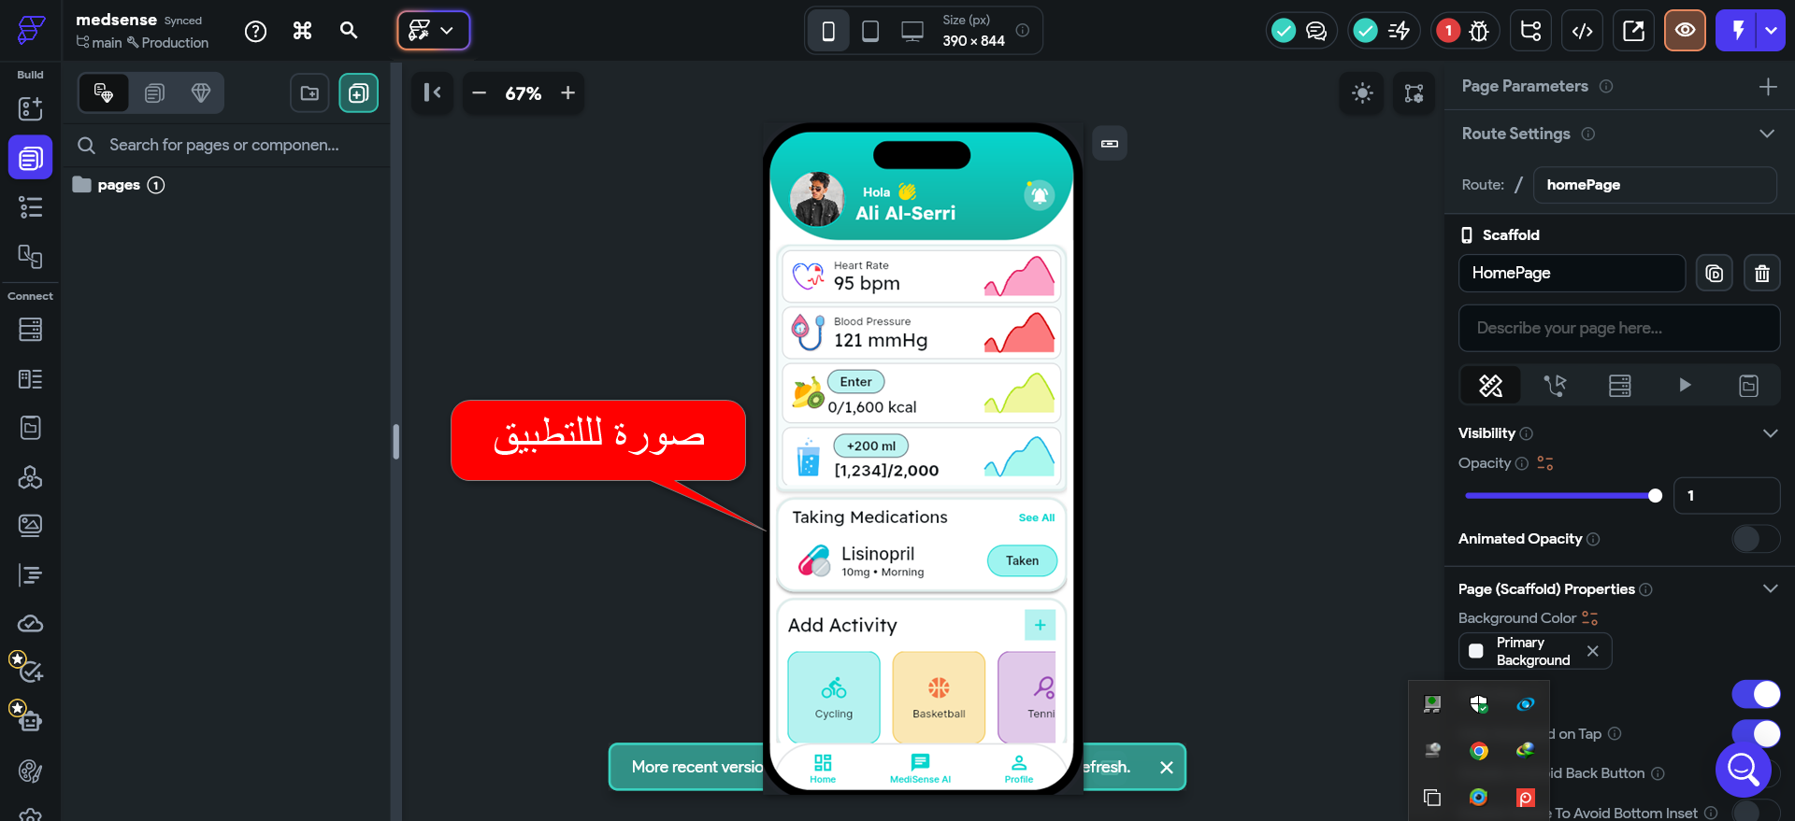
Figure 3.1: Screenshot of the application from inside Flutterflow

Chapter 4: Feedback and Findings
The industrial training at Digital Art for Trading proved to be a transformative experience, both technically and personally. This chapter provides a critical analysis of the skills acquired, knowledge applied, and feedback received throughout the 13-week placement. It also explores the alignment between academic learning and practical application, offering insights into areas where university instruction was reinforced, challenged, or expanded through hands-on engagement.
- 4.1 Alignment with Academic Knowledge
One of the most rewarding aspects of this training was the opportunity to apply theoretical knowledge in real-world development scenarios. Concepts from university courses such as Mobile App Development, Cloud Computing, and Database Management were directly relevant to my tasks. For instance:

Flutter Flow served as a practical extension of topics discussed in front-end design and user interaction modules.

Firebase allowed me to experience database connectivity, authentication, and data storage—all of which were previously explored only at a conceptual level.

System flow, page navigation, and data modeling learned in class were applied in designing real-life healthcare app architectures.
However, the training also exposed limitations in the scope of academic exercises. Real-world projects required greater attention to detail, version control practices, multi-platform testing, and collaborative problem-solving—all of which demand a depth and speed rarely replicated in academic assignments.
- 4.2 Feedback from Supervisors
Throughout the training, I received ongoing feedback from my external supervisor, Eng. Ahmed Al-Kumaim, and from peer developers within the technical team. Feedback was both constructive and encouraging, often delivered during live code reviews, design evaluations, and sprint retrospectives.

Key feedback themes included:

Proactivity: I was commended for taking initiative in proposing improvements to page layout and simplifying database queries.

Problem-Solving: My ability to identify UI bottlenecks and implement alternate navigation paths was highlighted as a strength.

Responsiveness: I demonstrated adaptability in quickly learning new tools and refining components based on real-time feedback.

Attention to Detail: I was advised to improve initial component alignment and maintain consistent design patterns—an essential lesson in production-level quality assurance.

This ongoing feedback cycle significantly accelerated my development as a junior developer and deepened my awareness of industry expectations.
- 4.3 Observations and Key Learnings

Several key findings emerged from my immersion in this professional environment:

Agile Development is Practical, Not Theoretical: Deadlines are not just academic targets; they impact real deliverables. Working in short sprints trained me to prioritize, estimate, and complete tasks under real-world time constraints.

Tools Matter: Exposure to low-code platforms such as Flutter Flow challenged my traditional coding mindset. I learned that tools evolve, and adaptability is more important than mastery of a single language or framework.

Teamwork is Fundamental: Unlike individual academic projects, industry work requires constant communication, peer review, and constructive negotiation. Collaborating with UI designers and backend developers taught me to appreciate multidisciplinary dynamics.

Error Handling is a Core Skill: Whereas university assignments may overlook graceful error handling, real-world applications must anticipate and recover from failure states—especially in healthcare-related interfaces where data accuracy and reliability are critical.

- 4.4 Reflection on Personal Growth

The training period was not without challenges. Balancing academic lectures, especially in Mobile application development and Entrepreneurship and Cloud Computing, alongside technical commitments was demanding. However, this dual pressure taught me resilience, focus, and strategic time management.

The experience also redefined my understanding of professionalism. Punctuality, initiative, documentation, and communication became just as important as writing functional code. My confidence in presenting my ideas, justifying design decisions, and debugging under pressure has improved measurably.

Most importantly, the internship reinforced my passion for applied technology and affirmed my desire to pursue a career in full-stack mobile development.
- 4.5 Challenges Encountered and How They Were Overcome
Throughout my training, I encountered several key challenges that contributed meaningfully to my personal and professional development:

• Bridging theory with practice:

Transitioning from academic coursework to real-world app development was initially overwhelming. The practical use of Flutter Flow and Firebase demanded faster learning and adaptability.
• Firebase integration issues:

Early attempts at connecting UI components with Firestore and authentication services led to broken bindings and logic errors. I resolved this by consulting documentation, restructuring data collections, and applying step-by-step debugging.

• UI consistency across pages:
Managing design uniformity across multiple screens proved challenging. I addressed this by creating reusable components and adopting a modular design strategy.
• Balancing academic and internship responsibilities:
Concurrent university lectures and project tasks created time pressure. I implemented a fixed routine, aligned expectations with both supervisors, and prioritized deliverables accordingly.

Each of these challenges tested different aspects of my professional readiness and ultimately strengthened my technical problem-solving, time management, and communication skills.

Chapter 5: Conclusion and Recommendations Training Analysis
The 13-week industrial training at Digital Art for Trading marked a defining chapter in my academic and professional journey. More than a graduation requirement, this experience was a transformative passage from theory to practice—offering insights, discipline, and growth that no classroom could replicate in isolation.

5.1 Conclusion
Over the course of the internship, I was entrusted with real development responsibilities—from user interface design and database structuring to full app deployment. Working on a health monitoring mobile application using Flutter Flow and Firebase not only refined my technical skills, but also reshaped the way I approach challenges, collaboration, and deadlines.

The practical environment pushed me beyond code. It taught me to ask the right questions, document my progress meticulously, communicate with stakeholders, and iterate under pressure. By participating in team discussions, peer reviews, and client-driven iterations, I learned that professional excellence is not solely defined by technical competence, but also by clarity, empathy, and adaptability.

Furthermore, the training validated the relevance of the academic curriculum at Twintech. Core subjects such as Database Management, Mobile App Development, and Entrepreneurship directly fed into the tasks I executed, highlighting a successful alignment between educational goals and industry expectations.

This internship helped me discover my interest in full-stack mobile development and inspired me to pursue further growth in cloud-integrated app design and scalable UI architecture. It also strengthened my career vision and gave me a clearer understanding of the type of engineer I aspire to become—innovative, reliable, and human-centered.

5.2 Recommendations to the Company
1. Expand AI-Driven Features:
Given the company’s growing focus on smart applications, investing in AI-enhanced functionalities—such as predictive health alerts, chatbot integration, or anomaly detection—could significantly elevate the impact of future projects.
2. Launch a Cloud-Based Subscription Model:
Offering a tiered cloud service model for clients could create recurring revenue streams while improving customer retention and scalability of digital services.
3. Improve Developer Infrastructure:
Upgrading internal hardware, increasing cloud resource allocation, and adopting centralized code versioning systems like GitHub or GitLab would optimize workflow, especially for teams handling multiple applications simultaneously.
4. Continue and Expand Internship Programs:
The company’s hands-on training model is highly effective. Formalizing mentorship plans, offering mini-projects, and connecting interns with alumni could create a continuous pipeline of tech talent.
5.3 Recommendations to the University
1. Integrate Tools like Flutter Flow and Firebase into Curriculum:
Given the increasing popularity of low-code and real-time cloud platforms in the industry, introducing these tools early in academic courses would better prepare students for modern development roles.
2. Offer Pre-Internship Bootcamps:
Hosting short workshops on industry expectations, portfolio preparation, and collaborative development tools (like Git, Figma, Notion) would help students enter internships with more confidence and capability.
3. Promote Cross-Disciplinary Projects:
Encouraging collaboration between IT students and those in business or healthcare programs can lead to more innovative, realistic project outcomes that mirror the diversity of real-world teams.
4. Foster Industry Partnerships:
Establishing long-term collaborations with local tech firms—including Digital Art for Trading—would benefit both students and industry by aligning academic output with national technological needs.
In conclusion, this training was not merely an academic obligation—it was a defining experience that deepened my technical foundation, broadened my vision, and reinforced my belief in technology’s potential to create meaningful change. I leave this internship not only as a better student, but as a more capable, curious, and committed future developer.

APPENDICES
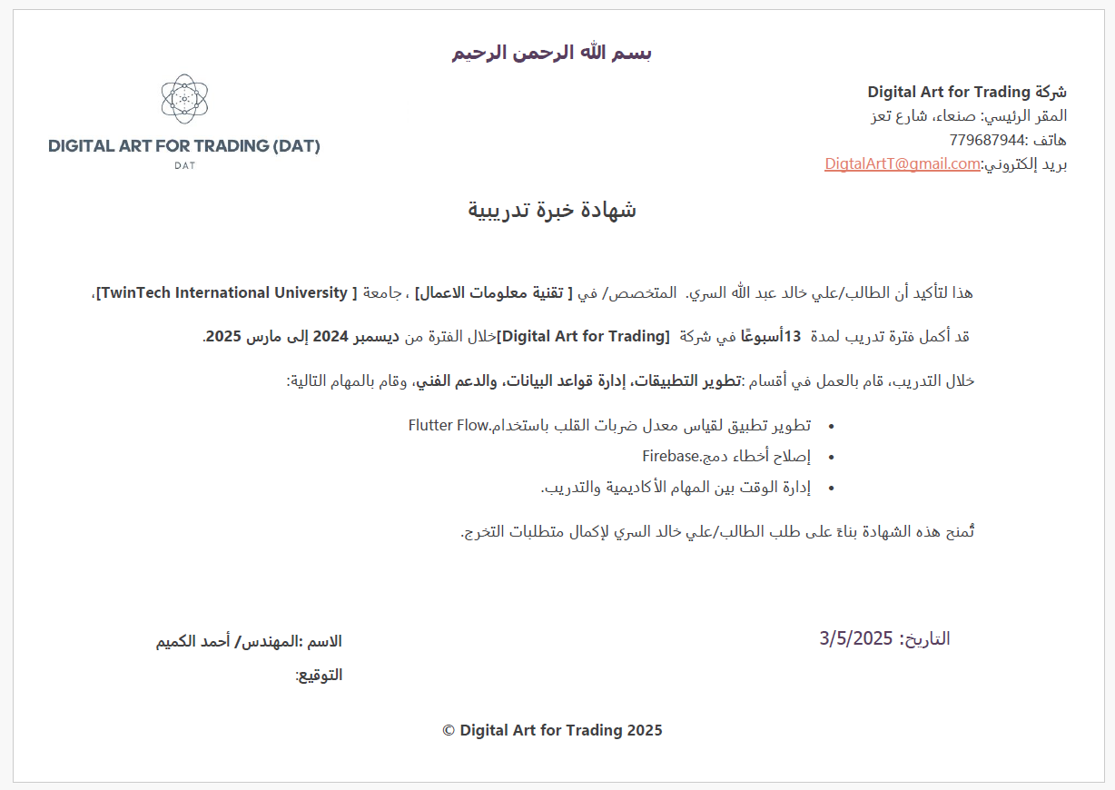
Appendix A: A copy of the training experience certificate from the company

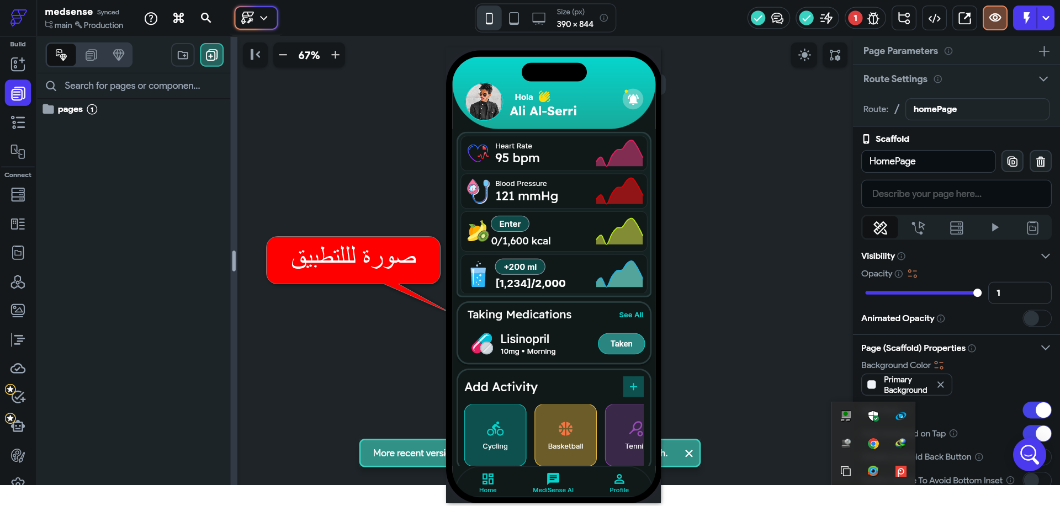
Appendix B: Screenshots of App Interfaces Designed in Flutter Flow

References
https://digitalarttring.com/
https://app.flutterflow.io/
https://console.firebase.google.com/

